Tesla coil

To explore the feasibility of using a tesla coil as an instrument three tesla coil kits were bought to test (shown in figure X). The turns ratio between the primary and Secondary coil is 350 as the power supply is 18V so the maximum voltage over the secondary coil is 6300V. As the electrical breakdown of air is 3kV/mm [1] so streamers with a length of 2.1mm can be expected from the unconnected end of the secondary coil.

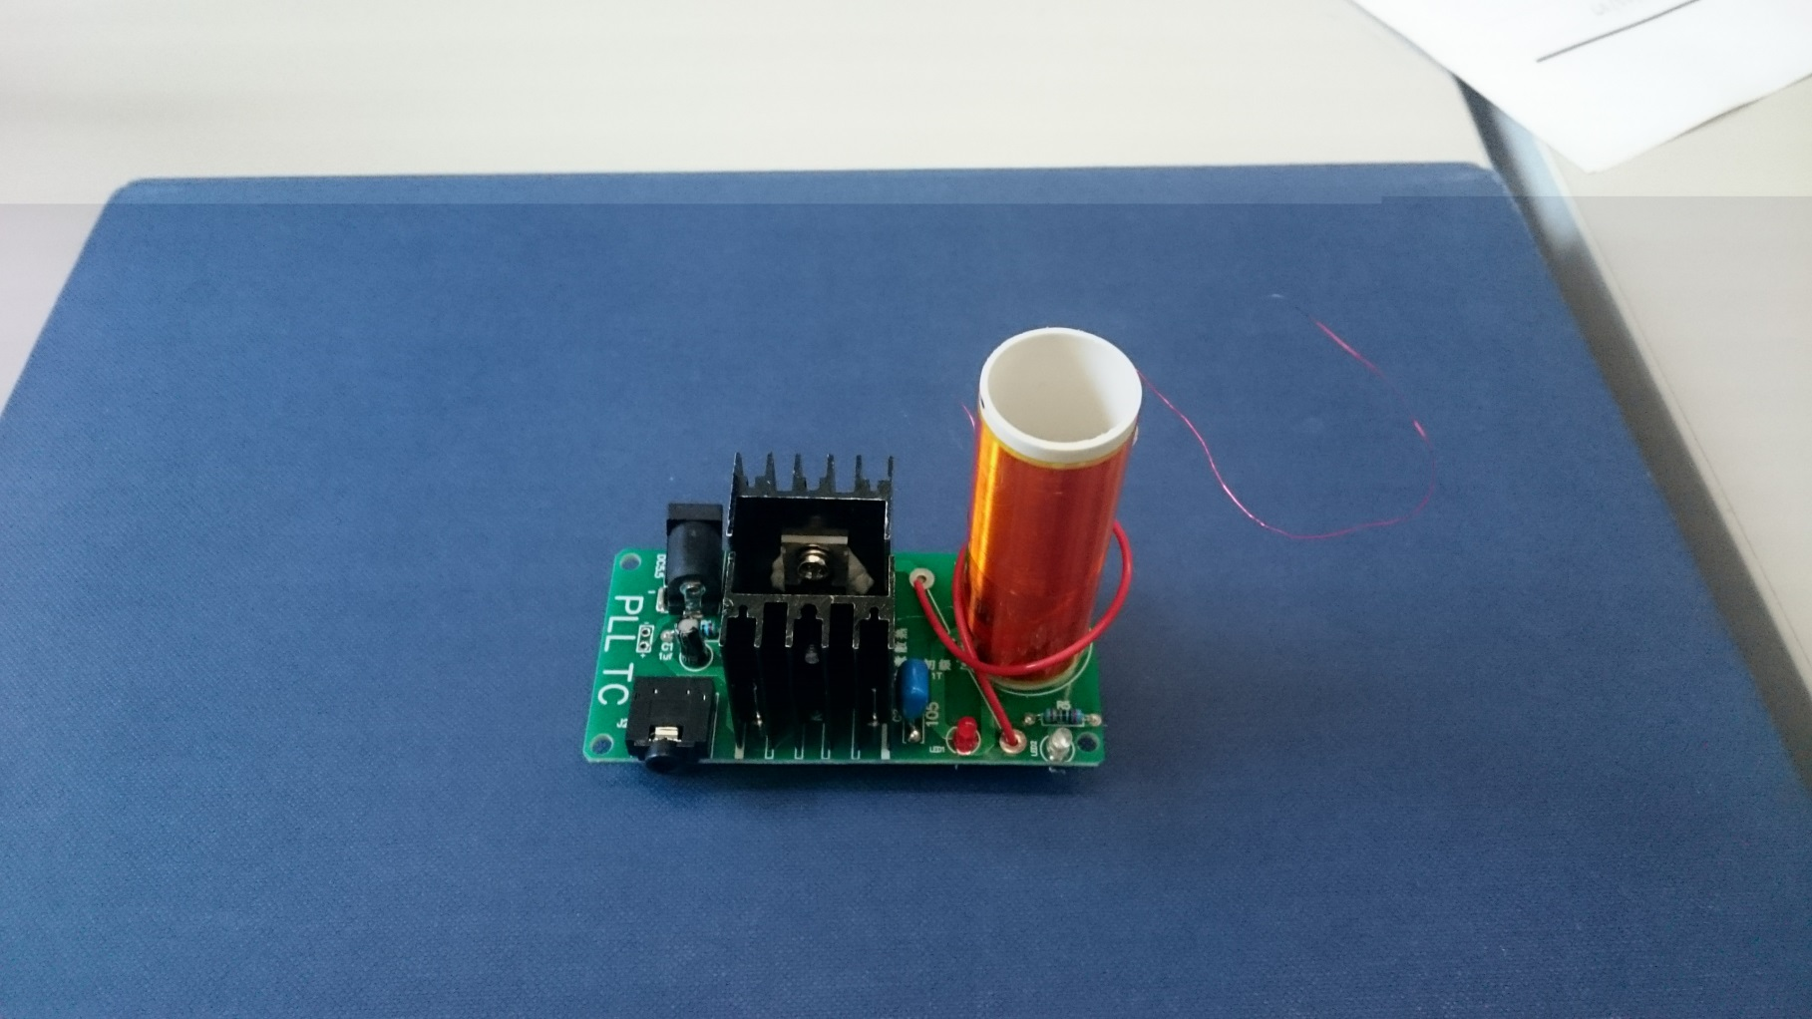

Secondary Coil

Primary Coil

Transistors with Heat Sinks

Unconnected end of Secondary coil

To play music through the tesla coil a phone is connected using a 3.4mm auxiliary input. The tesla coil was able to produce reasonably high sound quality however, it was quiet so a microphone and speaker would have to be setup if a tesla coil this size was being used. The volume could also be increased by making the tesla coil larger (YouTube example) but the sound quality is lower as the interference from the streamers is higher. To find out more about safety regarding tesla coils a meeting was arranged with Vidi who is a researcher at the high voltage lab at the University of Manchester. The risk surrounding tesla coils is low as although the voltage is high the current in the coil is very low and a cage could be placed around the coil to mitigate any risk. It could also be arranged to use the high voltage lab to test the tesla coil during development and there would be an opportunity to use the large tesla coil in the high voltage lab for the demonstration day.

# Bibliography

|  |  |
| --- | --- |
| [1] | Admin, "Breakdown voltage/Dielectric strength (Breakdown of Insulator)," The Physics Fact book, 15 September 2014. [Online]. Available: https://electronicspani.com/breakdown-voltagedielectric-strength/. [Accessed 23 November 2017]. |
|  |  |
|  |  |
|  |  |
|  |  |
|  |  |
|  |  |
|  |  |
|  |  |
|  |  |